**FEATURES OF U DEPLOY 6.2.1**

* Getting started page which have all the documentation.

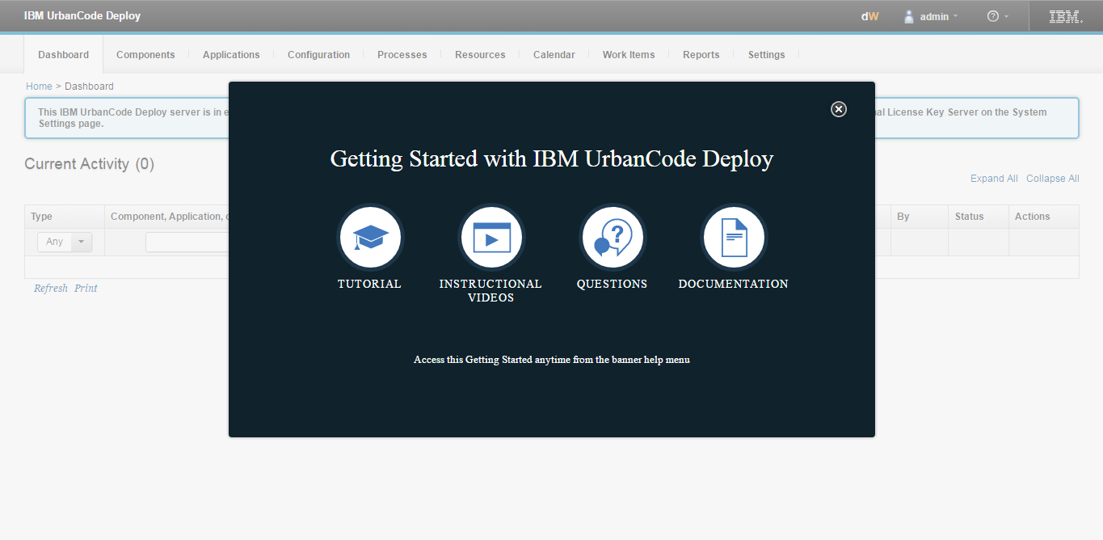

* Agent relay tab added in the resources.

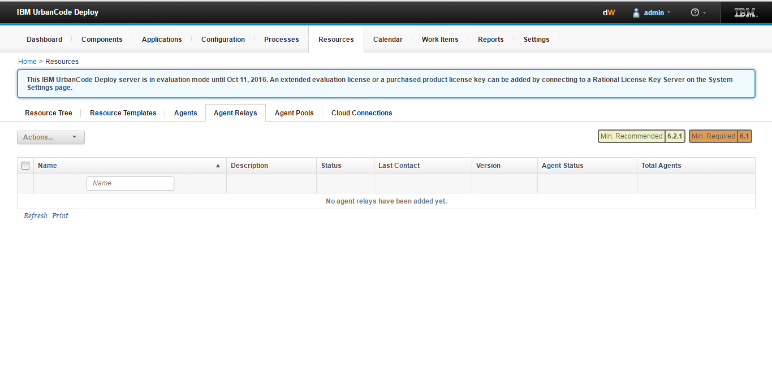

* Changes can be viewed from the changes tab inside a component.

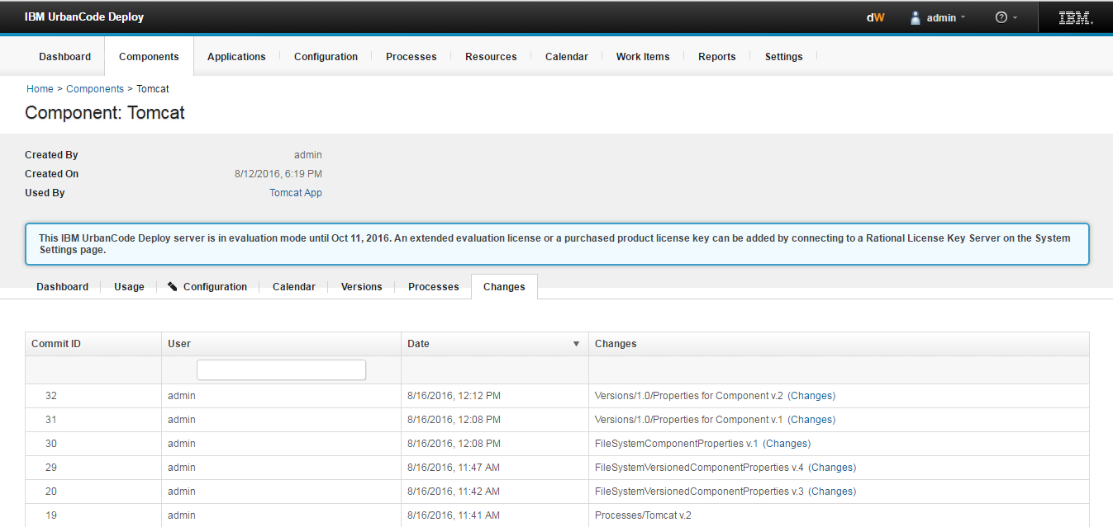

* Plugins are provided with new versions can be seen in automation plugins.Many new versions of plug-ins are available, including plug-ins for the following products and applications: Cognos, Siebel, Informatica, IBM Security AppScan Enterprise, IBM Aspera, IBM BigFix, IBM MQ, IBM InfoSphere DataStage, and Docker Compose.

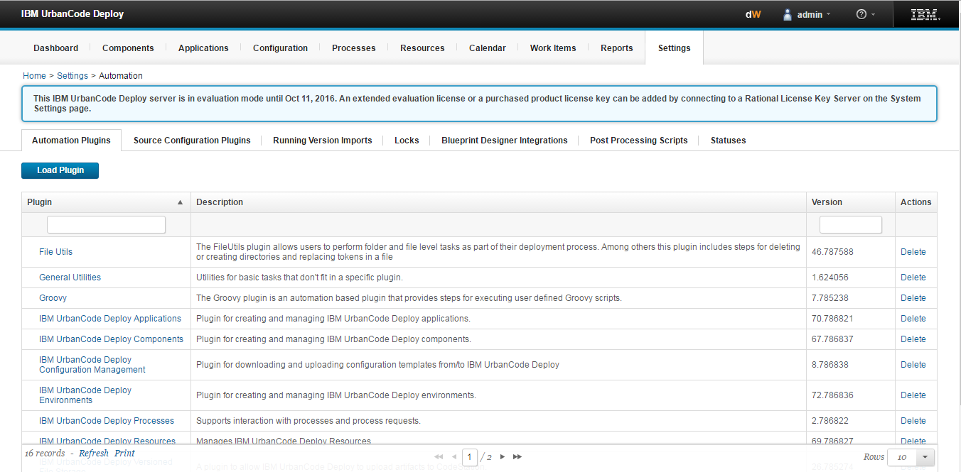

* API keys and certificates included in settings under security.

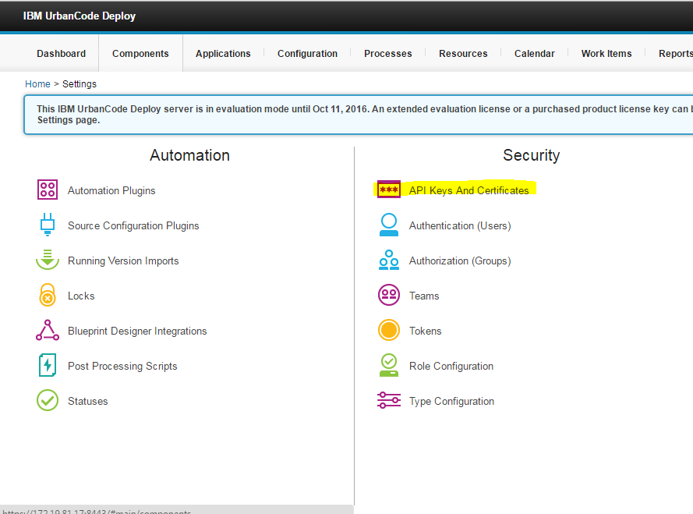

* When running the process click on the ADD option which is highlighted below there are list of options for the versions like latest available versions there are version lookups etc

